Economics
NAME
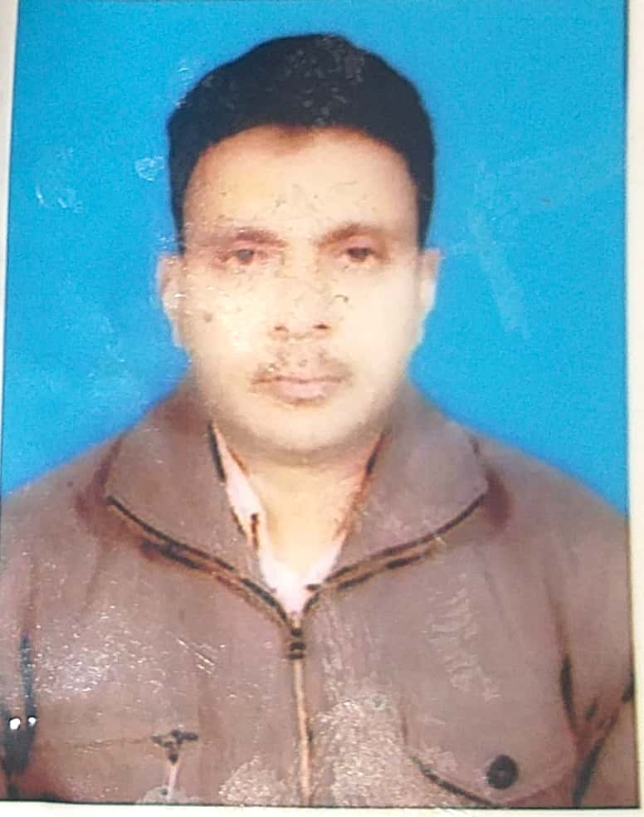

Dr. Mukesh kumar
DIGITAL PHOTOGRAPH

DESIGNATION | ASSISTANT PROFESSOR
DATE OF JOINING THIS COLLEGE | 09.07.2011
TEACHING EXPERIENCE,PG&UG | 12 years at UG level  1 and Half year at PG level
CONTACT NO. | 9835359717, 8210727058
EMAIL ID. | mukeshkumar220172@gmail.com
ACADEMIC QUALIFICATIONS | M.A, Bihar Eligibility Test(BET),Jharkhand Eligibility Test(JET),UGC, National Eligibility Test(NET),& Ph.D.
SPECIALIZATION/RESEARCH AREA | MATHEMATICAL ECONOMICS AND ECONOMETRICS
SUPERVISING RESEARCH SCHOLARS  /PURSUING RESEARCH | Pursuing 04 Research scholars
Research papers\ articles: | - Micro finance Intervention in sustainable development: An introduction- PRAMANA Research journal. ISSN; 2249-2976  - Integrated Approach to Marketing of Rural-farm products;- A few issues Introduction- Indian journal of Humanities. Volume- 01 issue 01, ISSN; 2248-9541  - Evaluation of Microfinance in India ,ISBN 978-81-8484-108-4  - Women Empowerment p.no.51-53  - Socio- Economic Empowerment of Rural Women through Micro Finance in India ,vol .4 ISSN 2320 9283  - Micro Finance : an effective weapon for socio economic empowerment of women ISSN 0975-0142  - Women Empowerment through Micro Finance/Credit ,ISBN 978-81-923984-4-0  - Aarthik Vikas me sushasan ,ISBN 978-93-84686-34-5  - Socio-Economic Empowerment Of Rural Women through Micro Finance in India. ISSN 2320-9283.  - Micro Finance :A comprehensive Review of the English Literature-
EDITIED\AUTHORED BOOKS: | - WOMEN EMPOWERMENT (Through Microfinance In Jharkhand)- published by AYUSHMAN PUBLICATION HOUSE NEW DELHI-110067 ,ISBN:978-93-5234-111  - FINANCIAL INCLUSION THROUGH MICROFINANCE INSTITUTION- AYUSHMAN PUBLICATION HOUSE- NEW DELHI ISBN:978-93-5234-120-7
AFFILIATION/ ASSOCIATION WITH JOURNALS | -----------------------

Member ship/ Felicitation/awards/Received | - Life member , Indian Economic Association(IEA)  - Life member ,Bihar Economic Association (BEA)
Achievements/ Felicitation/Awards | ---------------------------------
Any other Relevant Information | Completed Minor Research project under the UGC scheme : Title - Micro finance ; A weapon for poverty Alleviation and Women Empowerment

